Name : Shreyash Shete
Batch : May 2022

SQL Assignment

Library System

Use the following Schema to perform the given set of assignment.

Tables-

Member – It contains information about the members
Column Name | Data Type | Description
Member_Id | Number(5) | Unique Member ID
Member_Name | Varchar2(30) | Name of the Library member
Member_address | Varchar2(50) | Address of the member
Acc_Open_Date | Date | Date of membership
Membership_type | Varchar2(20) | Type of the membership such as ‘Lifetime’,’ Annual’,  ‘Half Yearly’,’ Quarterly’
Fees_paid | Number(4) | Membership fees paid
Max_Books_Allowed | Number(2) | Total Number of books that can be issued to the member.
Penalty_Amount | Number(7,2) | Penalty amount due

Books- It contains information about the books belongs to the library
Column Name | Data Type | Description
Book_No | Number(6) | Book identification number
Book_Name | VarChar2(30) | Name of the book
Author_name | Varchar2(30) | Author of the book
Cost | Number(7,2) | Cost of the book
Category | Char(10) | Category like Science , Fiction etc.

Issue – It contains the information about issue of the books
Column Name | Data Type | Description
Lib_Issue_Id | Number(10) | Library Book Issue No
Book_No | Number(6) | Number of the book issued
Member_Id | Number(5) | Member that issued the book
Issue_Date | Date | Date of Issue
Return_date | Date | Return date

Day # 2 Assignments (Estimated Time: 2 Hrs)

Concept: Select Command
SQL operators and functions
Single Row functions: Date, Numeric, Character functions,
Aggregate functions.

Objective: At the end of the assignments, participants will be confident to understand basic select query, Logical, Arithmetic operators, Date, character, Numeric function and regular expression functions. Aggregate functions and their use.

Task / Problems:

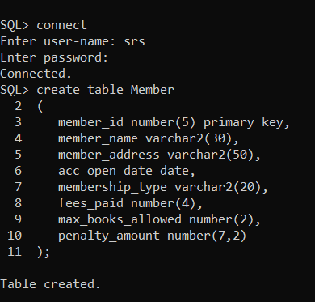
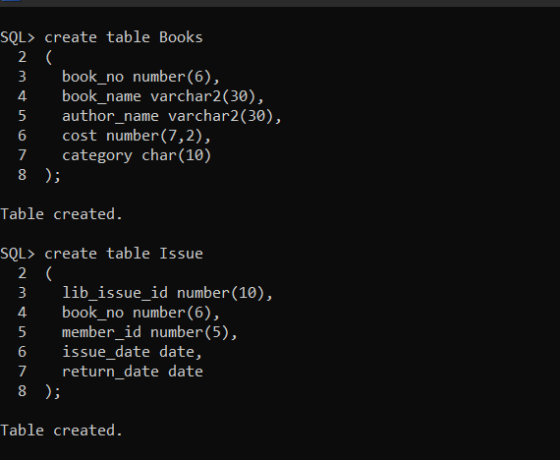

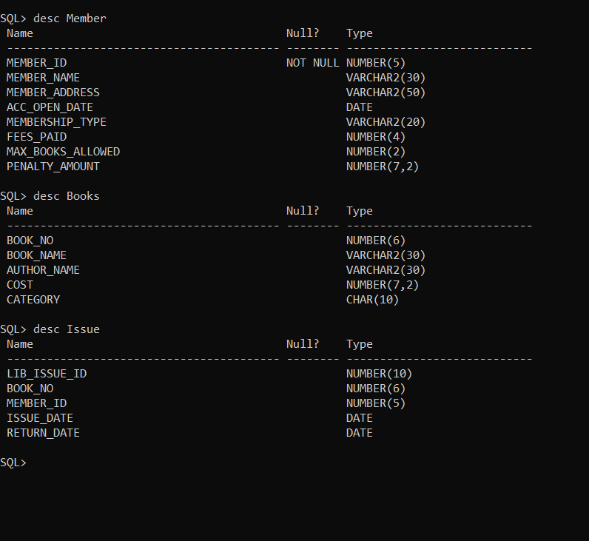

- List all the books that are written by Author Loni and has price
less then 600.

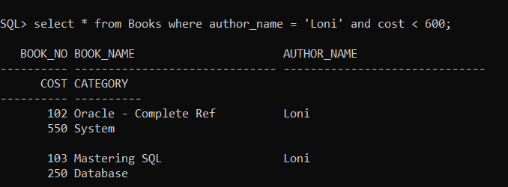

- List the Issue details for the books that are not returned yet.

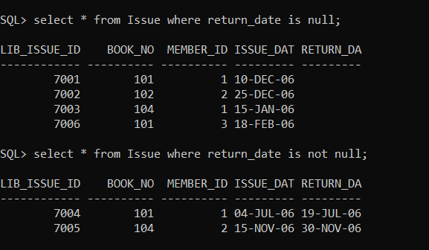

- Update all the blank return_date with 31-Dec-06 excluding 7005 and 7006.

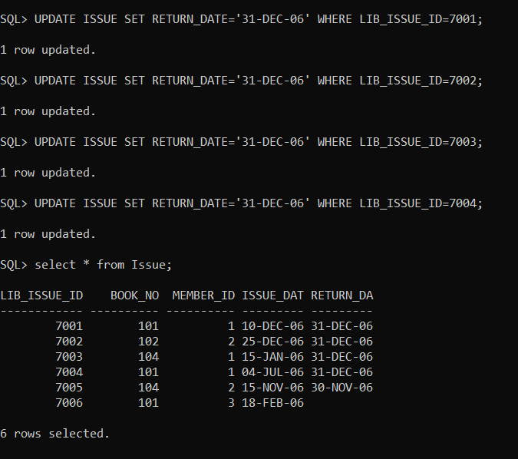

- List all the Issue details that have books issued for more then 30 days.

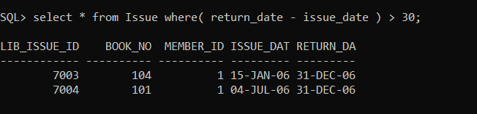

- List all the books that have price in range of 500 to 750 and has category as Database.

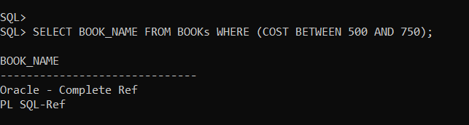

- List all the books that belong to any one of the following categories Science, Database, Fiction, Management.

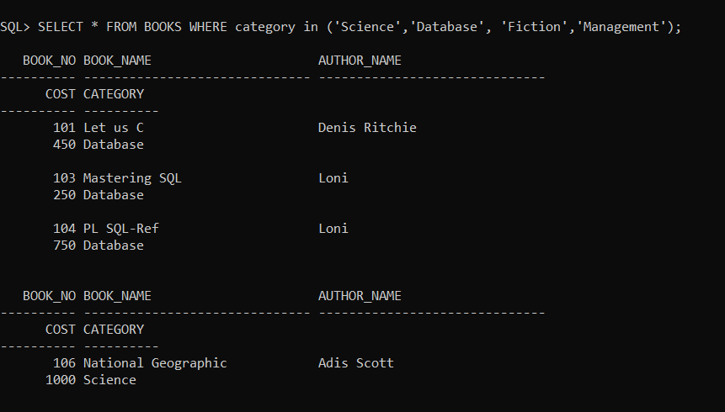

- List all the members in the descending order of Penalty due on them.

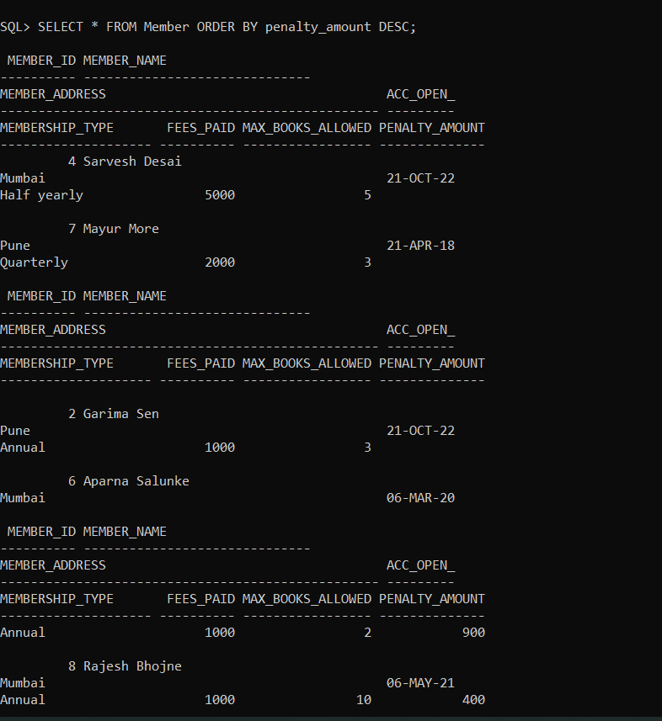

- List all the books in ascending order of category and descending order of price.

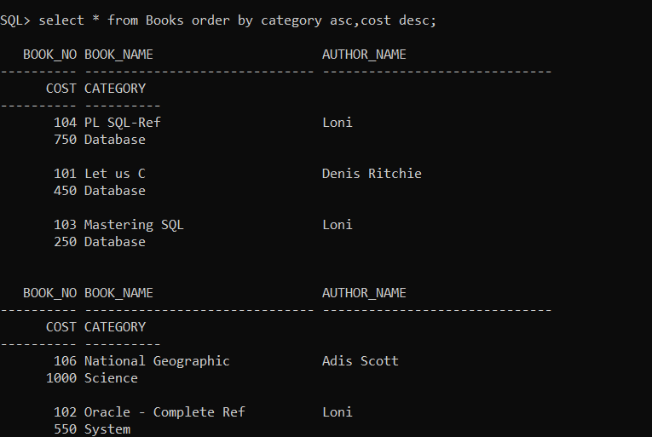

- List all the books that contain word SQL in the name of the book.

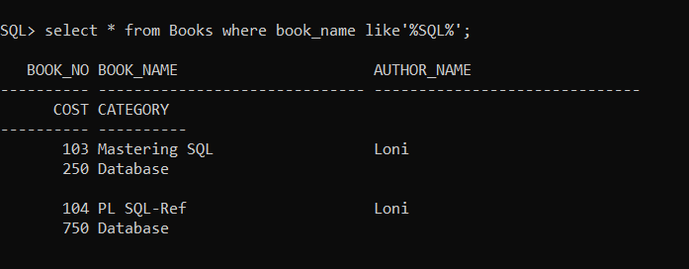

- List all the members whose name starts with R or G and contains letter I in it.

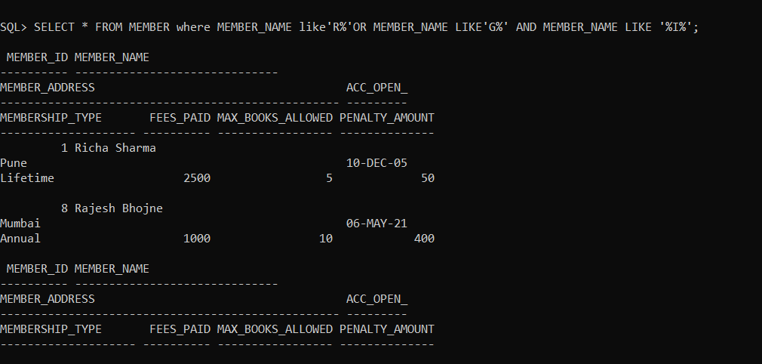

- List the entire book name in Init cap and author in upper case in the descending order of the book name.

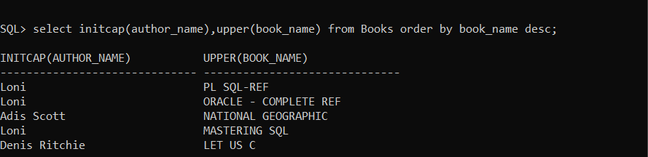

- List the Issue Details for all the books issue by member 101
with Issue_date and Return Date in following format. ‘Monday,
July, 10, 2006’.

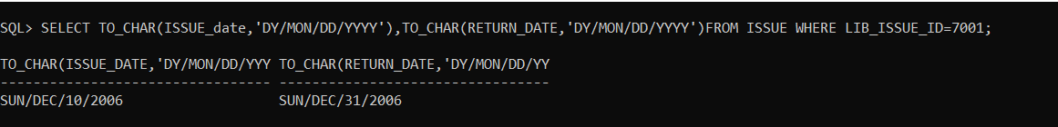

- List the data in the book table with category data displayed as
D for Database, S for Science, R for RDBMS and O for all the
others.

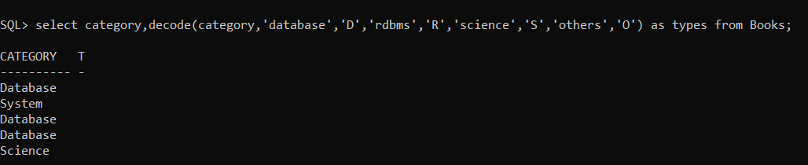

- List all the members that became the member in the year 2006.

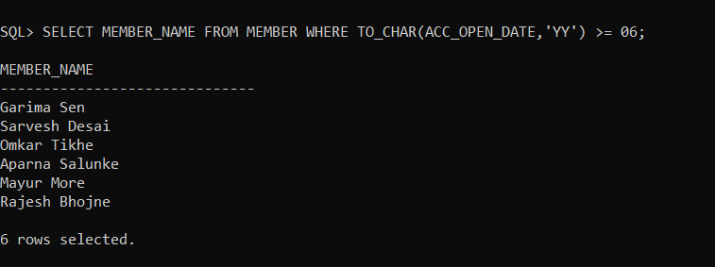

- List the Lib_Issue_Id, Issue_Date, Return_Date and No of days
Book was issued.

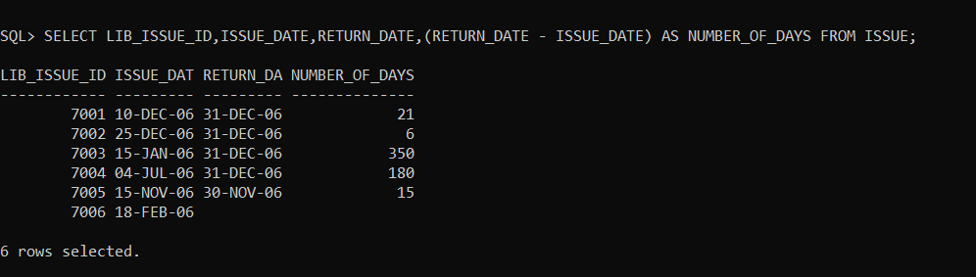

- Find the details of the member of the Library in the order of their
joining the library.

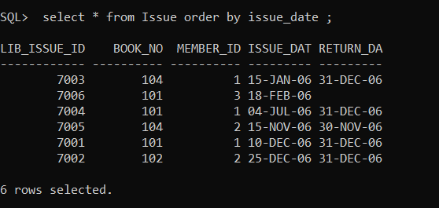

- Display the count of total no of books issued to Member 101.

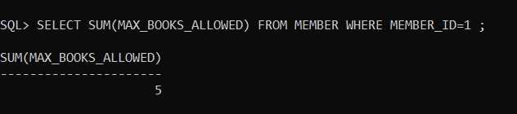

- Display the total penalty due for all the members.

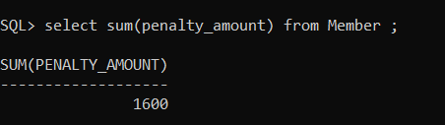

- Display the total no of members

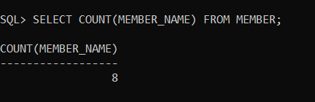

- Display the total no of books issued

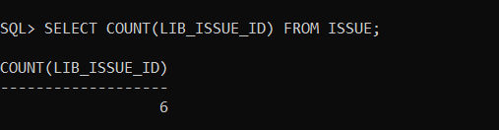

- Display the average membership fees paid by all the members

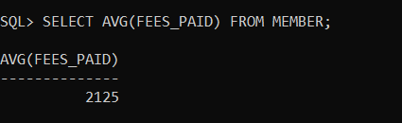

- Display no of months between issue date and return date for all issue

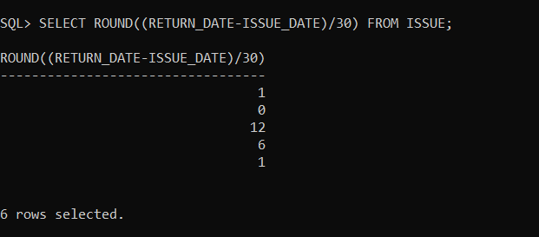

- Display the length of member’s name

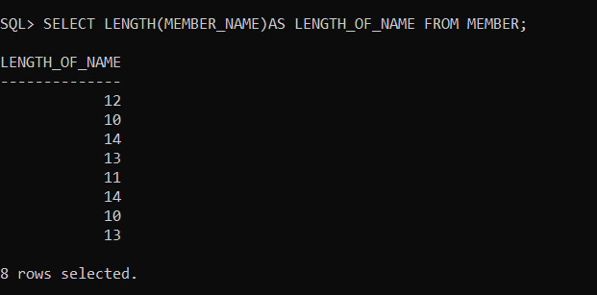

- Display the first 5 characters of membership_type for all members

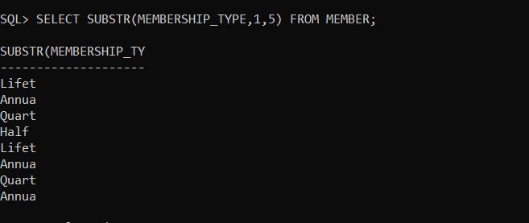

- Display the last day of the month of issue date

